- List the names of the 5 youngest employees in the company.
SELECT f_name, l_name, age
FROM employee_data
ORDER BY age ASC
LIMIT 5;
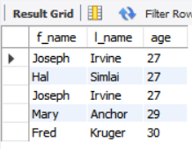

- Extract the next 5 entries starting with the 10th row.
SELECT *
FROM employee_data
LIMIT 9, 5;
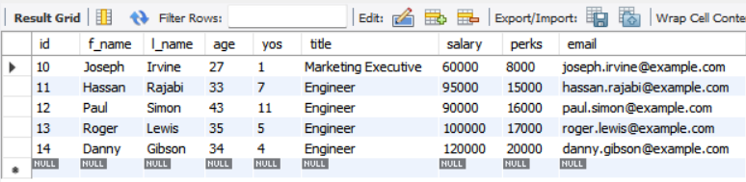

- Display the names and salary of the employee who draws the largest salary.
SELECT f_name, l_name, salary
FROM employee_data
ORDER BY salary DESC
LIMIT 1;
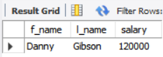

- What does the following statement display?
SELECT id, age, perks
FROM employee_data
ORDER BY perks DESC
LIMIT 10;
